NAAN MUDHAVAN ASSIGNMENT DOCUMENT

**COURSE TITLE** : DIGITAL MARKETING

**COLLEGE CODE** 1105

**COLLEGE NAME** : GOJAN SCHOOL OF BUSINESS AND TECHNOLOGY

**NM ID NAME**

**REGISTER NUMBER**

:5EB4BE7D9BD4C21A5BB44D6691FEEB63

: KAMALESH J

: 110520106317

**YEAR** : 4TH YEAR

**DEPARTMENT** : ELECTRONICS AND COMMUNICATION ENGINEERING

1. Create a blog or website using Blogspot and Wordpress. Customize the theme design and post new article with 500 words.

Link: [https://chefkamaleshrestaurant.blogspot.com/2023/10/chef-kamalesh-restaurant.html?m=](https://chefkamaleshrestaurant.blogspot.com/2023/10/chef-kamalesh-restaurant.html?m=1)1



1. Create a New Facebook Or Social Media Business Page and post one social media poster for your Brand

Link: [https://www.instagram.com/arun_icecream2023?igshid=OGQ5ZDc2ODk2ZA%3D%3D](https://instagram.com/chefkamaleshrestaurant?igshid=OGQ5ZDc2ODk2ZA%3D%3D)

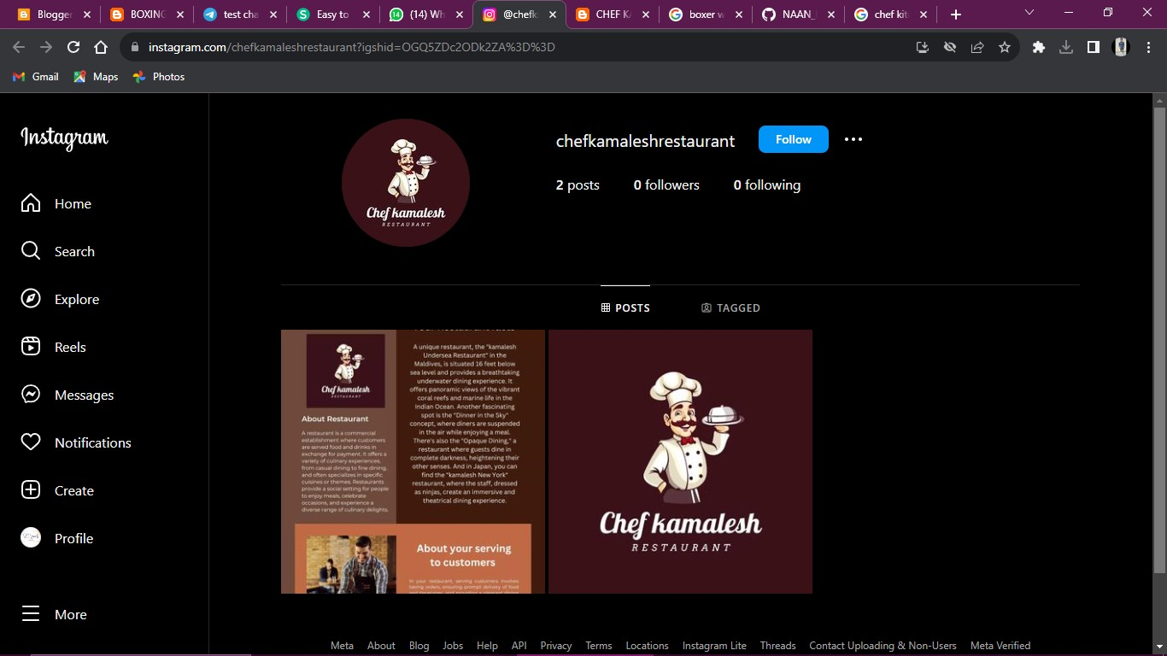

1. Create and design a social media advertisement poster using canva.

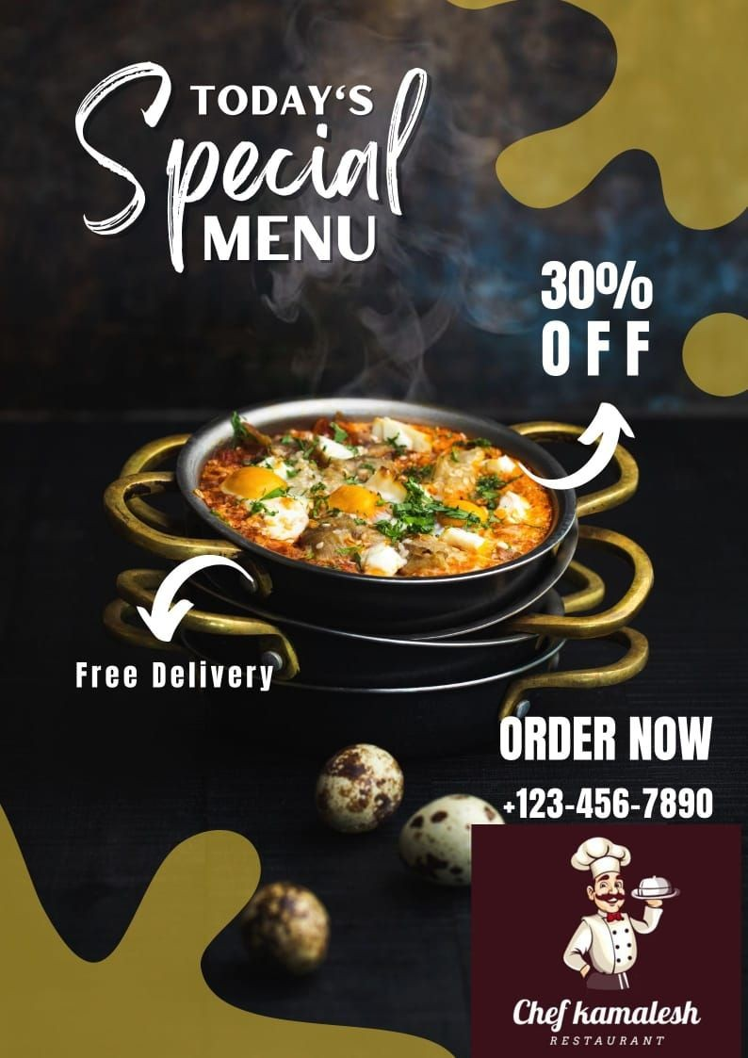

1. Create email newsletter design using MailChimp or canva tool.

Link: <https://chefkamaleshrestaurant.blogspot.com/2023/10/news-letter.html?m=1>

